## Research Proposal

Joris Peters (s4001109) – MAR 4th 22

**Part 1: The research question and its motivation**

* What is the research question that you want to answer, the problem you want to solve?

Given are a set of time-series, each composed of one or more behavior patterns. For example, a data set could be composed of time-series each encoding a stick figure during different activities; in each sample, the stick figure might go from running to jumping to sitting in any order and combination. The task is to regenerate such scenes in any free order. Conceptors, one of Herbert Jäger’s inventions, are a great tool to capture the underlying dynamics patterns in RNNs and to regenerate signals from these patterns. Thus, I wish to answer: Can mixed time-series data be decomposed into primitive sub-patterns using conceptors in an unsupervised way? (Potentially: And recombined in novel and meaningful ways)

* Why is this question/problem relevant? (From a theoretical and/or practical perspective)

This question is relevant because many real world time-extended data are composed of a mixture of underlying “primitive” components; a handwritten letter is composed of sequential small pen movements, or a robot’s movements are composed of sequential sub-movements. For these tasks it is unclear, how, given mixed signals as training data, these may be decomposed into subcomponents to be readily recombined to generate or simply analyze new mixed signal instances.

With this research, I hope to apply research in computational creativity (what we know from GANs, deep dream, creative analogies, computational models of cognition) to time-extended domains. I choose an unsupervised approach to decomposing time-series and with that a large degree of “algorithmic autonomy” in the process of generating novel and meaningful signals.

* What is already known? (Theories, earlier studies, unsolved questions)

Previously, the generation of mixed time-series like handwriting (Omniglot task) has poorly achieved by learning how to create the primitive strokes that underlie inidividual letters in a supervised manner and then recombining these strokes. This involves lots of human control, seems very artificial with a multistep pipeline, is not recombinable with new handwriting styles, and is not robust in the transition moments in the stroke of letters (corners of letters). Furthermore, combining many different types of signals could currently run the risk of catastrophic forgetting or require different RNNs.

This seems to be solved by using conceptors. Since 2014, papers have been published on this mathematical tool to capture, recognize, induce, denoise (and more) RNN activity. This literature will be used as a technical basis for this research. Nonetheless, it remains to be shown how conceptors can be used in unsupervised ways.

**Part 2: The location of your RQ on the 2 dimensions discussed in lecture 3**

* What type of research is your project with respect to the two dimensions --> indicate on the figure  
   I — fundamental, design, applied / problem solving  
  II — descriptive, exploratory, hypothesis-testing

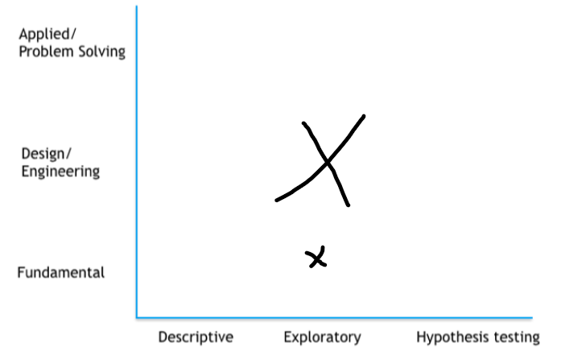

* Provide a short explanation/argumentation for your answer

My research is design and exploratory.

It is exploratory since it faces several unknowns and applies conceptors in a new (unsupervised) way. It is not descriptive since it requires the development of new algorithms, nor does it test a clear hypothesis; I have no benchmark or other clear hypotheses for the qualitative variables of *novelty* and *meaningfulness*. While they will be operationalized and compared to other work, it is not the focus and there is no a-priori hypothesis on them.

It is design since it aims to explore if the described system is possible. The design of the algorithm will be the main contribution. Still, the research is somewhat fundamental since conceptors are still a rather niche and theoretical topic. It is not, however, applied since a concrete real-world problem is not the focus.